Data
In order to help Karl to find the best location where to start the burger business, we need to retrieve the relevant, for our purposes, data about the city of Munich and in particular about the locations (districts) of this beautiful and big city.
To do that we used Wikipedia, Open Street map API’s and Foursquare.

Wikipedia at https://it.wikipedia.org/wiki/Monaco_di_Baviera to know the number and the names of all locations in Munich. (The picture shows the first 5 of 33 locations).
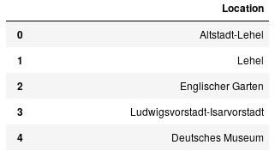

Coordinates(latitude, longitude) of those locations using Open Street Map API’s.

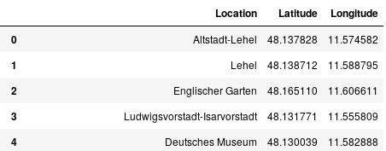

Foursquare API’s to find the venues data for each location:
  - the burger shop venues;
  - the schools venues;
  - the universities venues;
  - the offices venues.
At this point we know all the locations in Munich and also how many burgers, schools, universities and offices are present in each location. According with the weight given to the chosen parameters(burgers, schools, universities, offices) we will be able to find the best location where Karl could start his new business.

